Government of the People’s Republic of Bangladesh
Economic Relations Division
Ministry of Finance
UN Branch IV

PRESS RELEASE
Date: 07 December 2023

Subject: Economic Relations Division of Bangladesh and FAO Sign Four Technical Assistance Project Agreements

The Economic Relations Division (ERD) of the Ministry of Finance is delighted to announce the signing of four technical assistance project agreements with the Food and Agriculture Organization of the United Nations (FAO). These agreements, involving a total grant amount of USD 7.68 Million, will bolster various aspects of agriculture, food security, and nutrition in Bangladesh.

Details of the Projects:

1. Technical Assistance to the Diversified Resilient Agriculture for Improved Food and Nutrition Security Project (RAINS-TA)
2. Integrating Improved Agricultural Practices and Market Linkages to Enhance Nutrition and Incomes of Smallholder Farmers in Ukhiya and Kutubdia Subdistricts of Cox’s Bazar District
3. Acceleration of Economic and Social Inclusion of Smallholder Farmers through Strong Producers’ Organization (ACCESS)
4. Public-Private Blended Finance Facility for Climate Resilient Rice Landscape

Signatories of the Agreement:
The agreements were formally executed through the signatures of Md. Shahriar Kader Siddiky, Secretary of the Economic Relations Division, and Mr. Arnoud Hameleers, FAO Representative in Bangladesh. The signing ceremony was moderated by AKM Sohel, Wing Chief, UN Wing ERD.

Implementation Bodies:
The implementation of the first three projects will be led by the Department of Agricultural Extension, in collaboration with the Department of Agricultural Marketing, Department of Fisheries, Department of Livestock Services, Department of Primary Education and

Bangladesh Bank. The Bangladesh Rice Research Institute under the Ministry of Agriculture will implement the fourth project in collaboration with the Department of Environment and Department of Agricultural Extension.

FAO's Continued Support:
Since Bangladesh's membership in FAO in 1973, the country has received extensive technical and financial assistance, spanning various sectors. FAO's involvement has significantly contributed to 411 projects in Bangladesh, aligning with the objectives of the 8th Five Year Plan and the Sustainable Development Goals. This support underpins Bangladesh's efforts towards efficient, inclusive, resilient, and sustainable agri-food systems.

Alignment with FAO's Country Programming Framework:
These projects align with FAO's Country Programming Framework for 2022-2026, focusing on enhancing production, nutrition, environmental sustainability, and quality of life, ensuring no one is left behind.

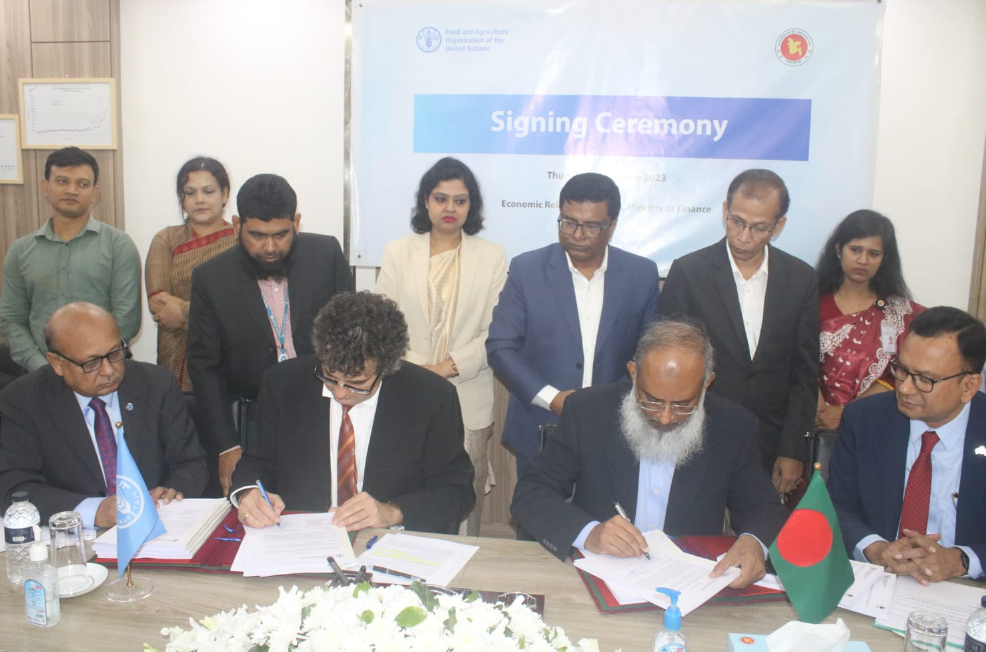
Project Signing Ceremony between Economic Relations Division & FAO

For Media Inquiries:
Mr. Bidhan Baral
Deputy Secretary
Economic Relations Division, Ministry of Finance
Cell: 01712 903630

